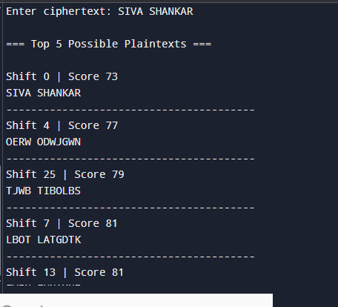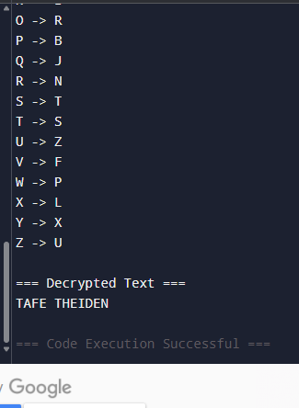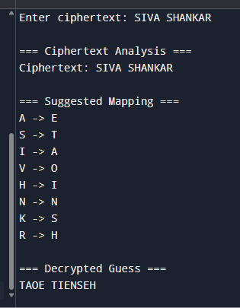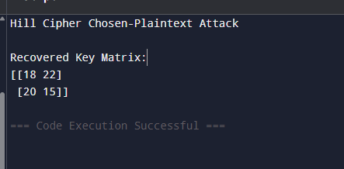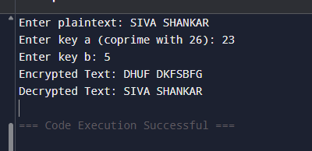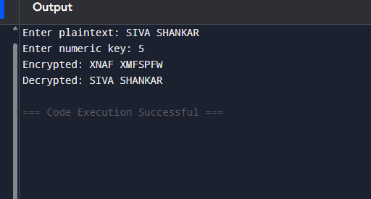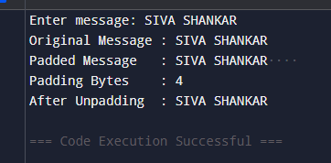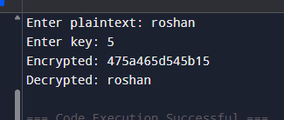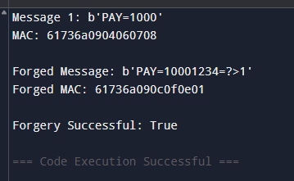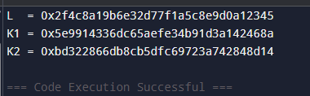

EXP 31:

from Crypto.Cipher import AES
RB = 0x87
def left_shift(block):
x = int.from_bytes(block, 'big')
x = (x << 1) & ((1 << 128) - 1)
return x.to_bytes(16, 'big')
def generate_subkeys(key):
aes = AES.new(key, AES.MODE_ECB)
L = aes.encrypt(b'\x00' * 16)
K1 = left_shift(L)
if L[0] & 0x80:
K1 = K1[:-1] + bytes([K1[-1] ^ RB])
K2 = left_shift(K1)
if K1[0] & 0x80:
K2 = K2[:-1] + bytes([K2[-1] ^ RB])
return K1, K2
key = b'0123456789abcdef'
k1, k2 = generate_subkeys(key)
print("K1 =", k1.hex())
print("K2 =", k2.hex())

EXP 32:

p = 23
q = 11
g = 2
x = 6
h = 9
def sign(k):
r = pow(g, k, p) % q
k_inv = pow(k, -1, q)
s = (k_inv * (h + x * r)) % q
return (r, s)
for k in [3, 5, 7]:
print("k =", k, "Signature =", sign(k))

EXP 33:

def encrypt(text, key):
result = ""
for i in range(len(text)):
t = ord(text[i])
k = ord(key[i % len(key)])
c = t ^ k
result += chr(c)
return result
def decrypt(cipher, key):
result = ""
for i in range(len(cipher)):
c = ord(cipher[i])
k = ord(key[i % len(key)])
t = c ^ k
result += chr(t)
return result
plaintext = input("Enter plaintext: ")
key = input("Enter key: ")
cipher = encrypt(plaintext, key)
print("Encrypted:", cipher.encode().hex())
decrypted = decrypt(cipher, key)
print("Decrypted:", decrypted)

EXP 34:

block_size = 8
message = input("Enter message: ")
padding_length = block_size - (len(message) % block_size)
padded_message = message + chr(padding_length) * padding_length
print("Original Message :", message)
print("Padded Message :", padded_message)
print("Padding Bytes :", padding_length)
unpadded_message = padded_message[:-ord(padded_message[-1])]
print("After Unpadding :", unpadded_message)

Exp 35:

plaintext = input("Enter plaintext: ").upper()
key = int(input("Enter numeric key: "))
cipher = ""
for ch in plaintext:
if ch.isalpha():
c = (ord(ch) - 65 + key) % 26
cipher += chr(c + 65)
else:
cipher += ch
print("Encrypted:", cipher)
decrypted = ""
for ch in cipher:
if ch.isalpha():
p = (ord(ch) - 65 - key) % 26
decrypted += chr(p + 65)
else:
decrypted += ch
print("Decrypted:", decrypted)

Exp 36:

def mod_inverse(a, m):
for x in range(1, m):
if (a * x) % m == 1:
return x
return None
plaintext = input("Enter plaintext: ").upper()
a = int(input("Enter key a (coprime with 26): "))
b = int(input("Enter key b: "))
cipher = ""
for ch in plaintext:
if ch.isalpha():
p = ord(ch) - 65
c = (a * p + b) % 26
cipher += chr(c + 65)
else:
cipher += ch
print("Encrypted Text:", cipher)
a_inv = mod_inverse(a, 26)
decrypted = ""
for ch in cipher:
if ch.isalpha():
c = ord(ch) - 65
p = (a_inv * (c - b)) % 26
decrypted += chr(p + 65)
else:
decrypted += ch
print("Decrypted Text:", decrypted)

Exp 37:

from collections import Counter
import string
ENGLISH_FREQ_ORDER = "ETAOINSHRDLCUMWFGYPBVKJXQZ"
def frequency_attack(ciphertext):
text = ''.join([c.upper() for c in ciphertext if c.isalpha()])
freq = Counter(text)
sorted_cipher_letters = [item[0] for item in freq.most_common()]
mapping = {}
for i, letter in enumerate(sorted_cipher_letters):
if i < len(ENGLISH_FREQ_ORDER):
mapping[letter] = ENGLISH_FREQ_ORDER[i]
decrypted = []
for char in ciphertext.upper():
if char in mapping:
decrypted.append(mapping[char])
else:
decrypted.append(char)
return ''.join(decrypted), mapping
def print_analysis(ciphertext):
decrypted, mapping = frequency_attack(ciphertext)
print("\n=== Ciphertext Analysis ===")
print("Ciphertext:", ciphertext)
print("\n=== Suggested Mapping ===")
for k, v in mapping.items():
print(f"{k} -> {v}")
print("\n=== Decrypted Guess ===")
print(decrypted)
if __name__ == "__main__":
text = input("Enter ciphertext: ")
print_analysis(text)

Exp 38:

import numpy as np
MOD = 26
def mod_inverse_matrix(matrix, mod):
det = int(round(np.linalg.det(matrix)))
det_inv = pow(det % mod, -1, mod)
adj = np.round(det * np.linalg.inv(matrix)).astype(int) % mod
return (det_inv * adj) % mod
def recover_key(plaintext_matrix, ciphertext_matrix):
P = np.array(plaintext_matrix)
C = np.array(ciphertext_matrix)
P_inv = mod_inverse_matrix(P, MOD)
K = np.dot(C, P_inv) % MOD
return K.astype(int)
if __name__ == "__main__":
print("Hill Cipher Chosen-Plaintext Attack")

P = [[3, 3],
[2, 5]]
C = [[20, 8],
[12, 5]]
key = recover_key(P, C)
print("\nRecovered Key Matrix:")
print(key)

Exp 39:

import string
from collections import Counter
ALPHABET = string.ascii_uppercase
ENGLISH_FREQ = "ETAOINSHRDLCUMWFGYPBVKJXQZ"
def decrypt_additive(ciphertext, shift):
result = []
for char in ciphertext.upper():
if char in ALPHABET:
idx = ALPHABET.index(char)
new_idx = (idx - shift) % 26
result.append(ALPHABET[new_idx])
else:
result.append(char)
return ''.join(result)
def score_text(text):
"""Basic frequency-based scoring (higher = more English-like)"""
text = text.upper()
freq = Counter(text)
score = 0
for letter, count in freq.items():
if letter in ENGLISH_FREQ:
# higher weight for common English letters
score += ENGLISH_FREQ.index(letter)

return score
def analyze_cipher(ciphertext):
results = []
for shift in range(26):
decrypted = decrypt_additive(ciphertext, shift)
score = score_text(decrypted)
results.append((score, shift, decrypted))
results.sort()
return results
if __name__ == "__main__":
cipher = input("Enter ciphertext: ")
results = analyze_cipher(cipher)
print("\n=== Top 5 Possible Plaintexts ===\n")
for score, shift, text in results[:5]:
print(f"Shift {shift} | Score {score}")
print(text)
print("-" * 40)

Exp 40:

import random
import string
from collections import Counter
ALPHABET = string.ascii_uppercase
COMMON_PAIRS = ["TH", "HE", "IN", "ER", "AN", "RE", "ON", "AT", "EN"]
def decrypt(ciphertext, key_map):
result = []
for c in ciphertext.upper():
if c in ALPHABET:
result.append(key_map[c])
else:
result.append(c)
return ''.join(result)
def score(text):
text = text.upper()

# Bigram scoring
bigram_score = 0
for pair in COMMON_PAIRS:
bigram_score += text.count(pair) * 5
freq = Counter(text)
common_letters = "ETAOINSHR"
for i, l in enumerate(common_letters):
bigram_score += freq.get(l, 0) * (len(common_letters) - i)
return bigram_score
def random_key():
shuffled = list(ALPHABET)
random.shuffle(shuffled)
return dict(zip(ALPHABET, shuffled))
def mutate_key(key):
a, b = random.sample(ALPHABET, 2)
new_key = key.copy()
inv = {v: k for k, v in new_key.items()}
inv[a], inv[b] = inv[b], inv[a]
return {k: inv[k] for k in ALPHABET}
def attack(ciphertext, iterations=5000):
key = random_key()
best_key = key
best_score = -1
for _ in range(iterations):
candidate = mutate_key(key)
decrypted = decrypt(ciphertext, candidate)
candidate_score = score(decrypted)
if candidate_score > best_score:
best_score = candidate_score
best_key = candidate
key = candidate
return best_key
if __name__ == "__main__":
cipher = input("Enter ciphertext: ")
key = attack(cipher)
print("\n=== Best Key Mapping ===")
for k, v in key.items():
print(f"{k} -> {v}")
print("\n=== Decrypted Text ===")
print(decrypt(cipher, key))

